**AUC - ROC Curve**

AUC - ROC curve is a performance measurement for classification problem at various thresholds settings. ROC is a probability curve and AUC represents degree or measure of separability. It tells how much model is capable of distinguishing between classes. Higher the AUC, better the model is at predicting 0s as 0s and 1s as 1s. By analogy, Higher the AUC, better the model is at distinguishing between patients with disease and no disease.

The ROC curve is plotted with TPR against the FPR where TPR is on y-axis and FPR is on the x-axis.

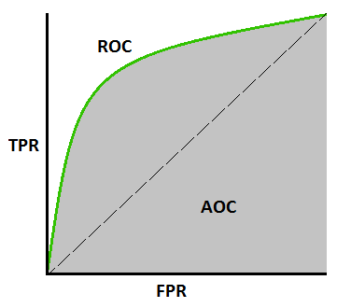AUC - ROC Curve

### ****Defining terms used in AUC and ROC Curve.****

#### ****TPR (True Positive Rate) / Recall /Sensitivity****

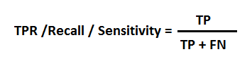

Image 3

#### ****Specificity****

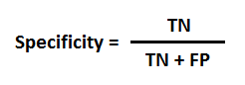

Image 4

#### FPR

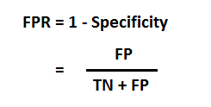

### ****How to speculate the performance of the model?****

An excellent model has AUC near to the 1 which means it has good measure of separability. A poor model has AUC near to the 0 which means it has worst measure of separability. In fact it means it is reciprocating the result. It is predicting 0s as 1s and 1s as 0s. And when AUC is 0.5, it means model has no class separation capacity whatsoever.

Let’s interpret above statements.

As we know, ROC is a curve of probability. So lets plot the distributions of those probabilities:

Note: Red distribution curve is of the positive class and green distribution curve is of negative class.

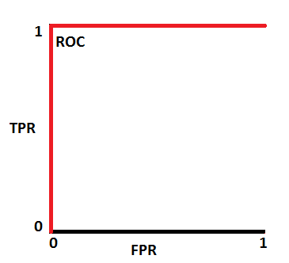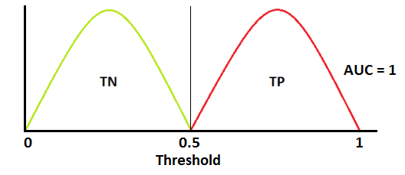

This is an ideal situation. When two curves don’t overlap at all means model has an ideal measure of separability. It is perfectly able to distinguish between positive class and negative class.

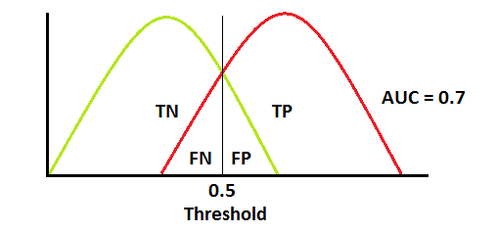

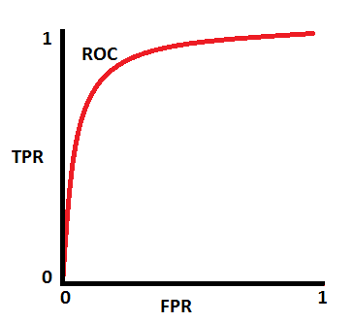

When two distributions overlap, we introduce type 1 and type 2 error. Depending upon the threshold, we can minimize or maximize them. When AUC is 0.7, it means there is 70% chance that model will be able to distinguish between positive class and negative class

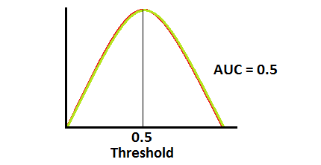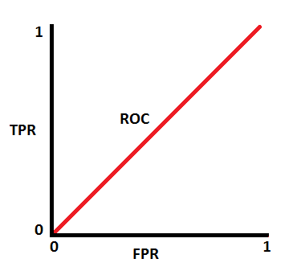

This is the worst situation. When AUC is approximately 0.5, model has no discrimination capacity to distinguish between positive class and negative class.

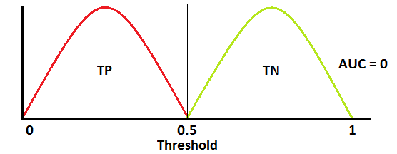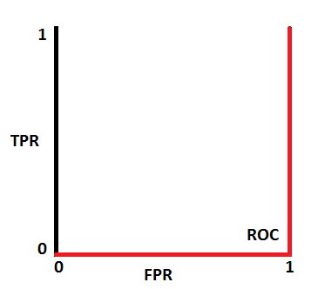

When AUC is approximately 0, model is actually reciprocating the classes. It means, model is predicting negative class as a positive class and vice versa.

**Relation between Sensitivity, Specificity, FPR and Threshold.**

Sensitivity and Specificity are inversely proportional to each other. So when we increase Sensitivity, Specificity decreases and vice versa.

*Sensitivity⬆️, Specificity⬇️ and Sensitivity⬇️, Specificity⬆️*

When we decrease the threshold, we get more positive values thus it increases the sensitivity and decreasing the specificity.

Similarly, when we increase the threshold, we get more negative values thus we get higher specificity and lower sensitivity.

As we know FPR is 1 - specificity. So when we increase TPR, FPR also increases and vice versa.

*TPR⬆️, FPR⬆️ and TPR⬇️, FPR⬇️*

**How to use AUC ROC curve for multi-class model?**

In multi-class model, we can plot N number of AUC ROC Curves for N number classes using One vs ALL methodology. So for Example, If you have **three**classes named **X, Y**and**Z**, you will have one ROC for X classified against Y and Z, another ROC for Y classified against X and Z, and a third one of Z classified against Y and X.

**REFERENCES**

<https://www.linkedin.com/in/sarangnarkhede/>